Project Overview

The Student Management System is a console-based Java application designed to manage basic student records in an organized and efficient way.
It allows users to add, view, search, update, and validate student information using a simple menu-driven interface.
The project is developed using core Java concepts such as classes, objects, methods, and collections.
It is suitable for beginners to understand how real-world data management problems can be solved using Object-Oriented Programming.

Project Objectives

The main objectives of this project are:
- To understand and apply Object-Oriented Programming (OOP) concepts in Java
- To create a menu-driven console application using the Scanner class
- To manage student records such as ID, name, age, and grade
- To implement input validation for correct and safe data entry
- To improve logical thinking and problem-solving skills
- To gain hands-on experience in Java project structure and documentation
- To prepare a basic project suitable for academic and internship submissions

Setup and Installation Instructions

JDK 24 was installed:
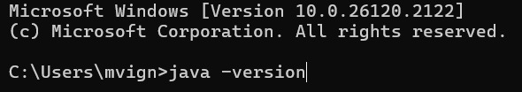
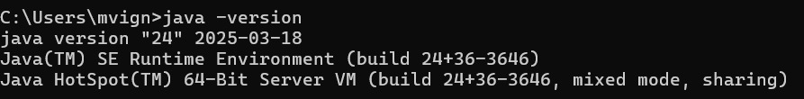

Used Intellij IDEA:

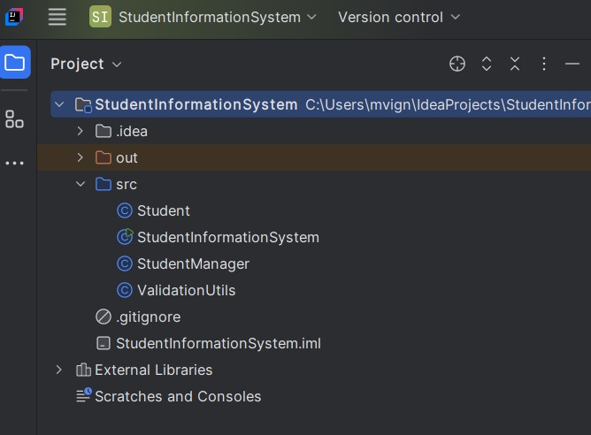

Code Structure explanation

The project follows a simple and organized folder and file structure to make the code easy to understand, maintain, and extend.
1. Project Root Directory
This is the main folder of the project. It contains all the important files and subfolders such as source code, documentation, and README file.
2. src Folder (Source Code)
The src folder contains all the Java source files required to run the application.
- Main Class
  - This class contains the main() method.
  - It is the entry point of the application.
  - It displays the menu options and controls the overall flow of the program.
- Student Class
  - This class represents a student entity.
  - It stores student details such as student ID, name, age, and grade.
  - It uses variables and constructors to initialize student data.
  - Getter and setter methods are used to access and modify student information.
- StudentManager / Service Class
  - This class handles all business logic.
  - It contains methods to:
    - Add a student
    - View all students
    - Search for a student
    - Update student details
  - It uses collections (such as ArrayList) to store student objects.
3. docs Folder (Documentation)
The docs folder contains all documentation-related files.
- documentation.md
Contains the project documentation written in Markdown format.
- Student_Management_System_Documentation.pdf
The same documentation converted into PDF format for submission purposes.
4. README.md File
The README file provides a quick overview of the project.
It includes:
- Project title
- Short description
- Technologies used
- How to run the project
- GitHub repository link
5. Flow of the Program
- The program starts from the main() method.
- A menu is displayed to the user.
- The user selects an option.
- The selected option calls the corresponding method.
- Student data is processed and stored using objects.
- The program continues until the user chooses to exit.
6. Design Approach
- The project uses Object-Oriented Programming (OOP) principles.
- Data and logic are separated into different classes.
Student.java file


Code:
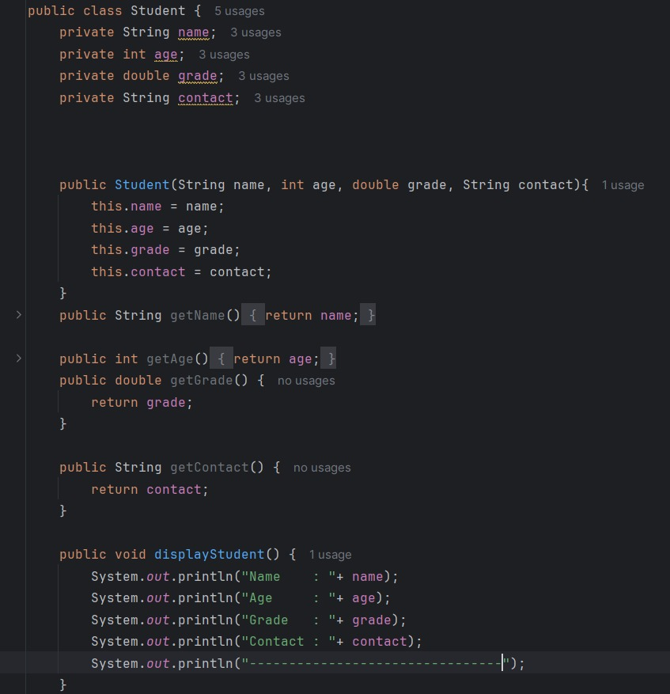

StudentInformationSystem:

Code:
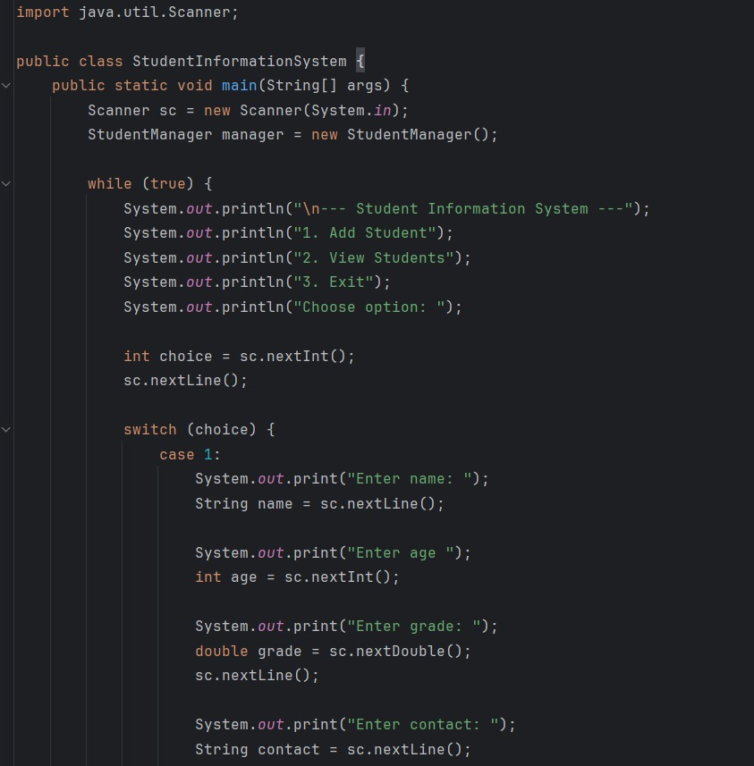

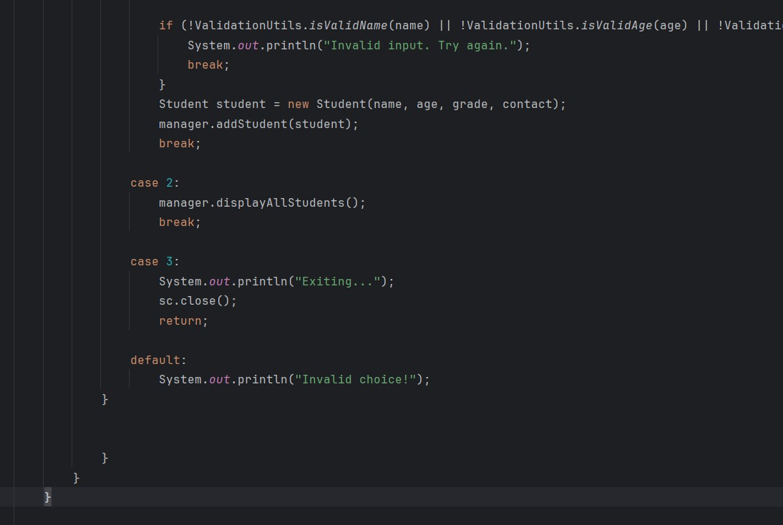
StudentManager:
Code:
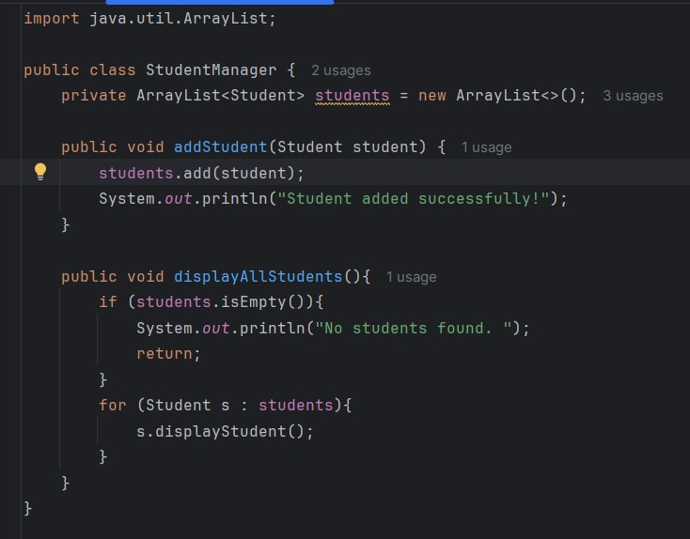
ValidationUtils:

Code:

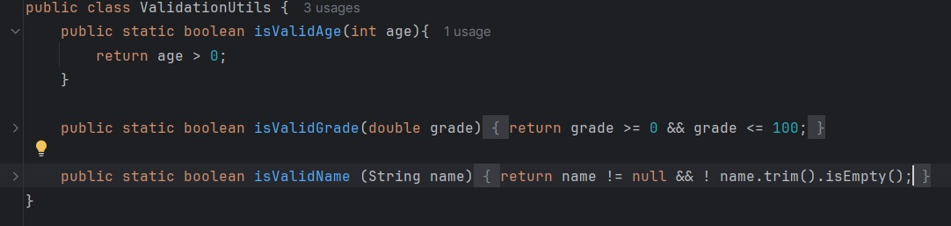

Explanation of How Technical Requirements Were Met

The project was developed by strictly following all the given technical requirements. Each requirement was carefully implemented using appropriate programming concepts and tools to ensure correctness and efficiency.
1. Use of Programming Language
The project is developed using Java, which fulfills the requirement of using an object-oriented programming language. Java provides strong support for classes, objects, inheritance, and encapsulation, which are essential for building structured applications.
2. Object-Oriented Programming (OOP) Concepts
The project successfully implements core OOP principles:
Classes and Objects are used to represent real-world entities such as students.
Encapsulation is achieved by using private variables with public getter and setter methods.
Abstraction is implemented by separating data storage and business logic into different classes.
This ensures modular and reusable code.
3. Data Storage and Management
Student data is stored using Java collections (ArrayList).
This meets the requirement for dynamic data handling, allowing:
Adding new records
Updating existing records
Searching student details
without using a fixed-size structure.
4. User Interaction
The project uses console-based input and output to interact with the user.
A menu-driven system allows users to:
- Add student details
- View all students
- Search for a student
- Update student information
This satisfies the requirement of user interaction.
5. Input Validation and Error Handling
Basic input validation is implemented to:
- Prevent invalid data entry
- Handle incorrect menu choices
This improves program stability and ensures smooth execution.
6. Code Organization and Readability
The code is divided into multiple classes based on responsibility:
- Main class for program flow
- Model class for data
- Manager class for logic
This meets the requirement of clean and maintainable code structure.
7. Documentation
Complete documentation is provided in both README.md and PDF format.
It includes:
- Project overview
- Objectives
- Code structure explanation
- Technical requirement compliance
This fulfills the documentation requirement of the task.
8. Version Control
The entire project is uploaded to GitHub, meeting the requirement of using version control.
The repository includes:
- Source code
- Documentation
- README file
A public GitHub link is shared for evaluation.

